Grapevine Community Outreach Center
&
GRACE (Scribner)
Summer Reading Program 2020
Volunteer Training Packet

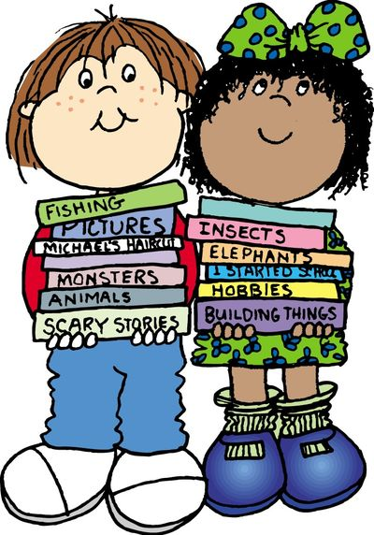

Welcome to Summer Reading Fun 2020
This summer will look different than in the past summers due to physical distancing and COVID-19.
We will be providing Summer Reading Fun at Community Outreach Center on Tuesdays and Thursdays from 11am – 1pm and at GRACE (old location off Scribner and Shady Brook) on Wednesdays from 12-1pm.
Summer Reading Fun is set to start the week of June 22nd and to wrap up the week of July 28th!
In order to ensure social distancing and proper cleaning of the rooms, below is the schedule and occupancy standards for each location.
Community Outreach Center – 3010 Mustang Dr., Grapevine, TX 76051
Days | Time(s) | Room | Max # of Kids/Adults
Tuesdays | 11:00am-11:30am | COC - Room A | 6 kids/6 volunteers
Tuesdays | 11:30am-12:00pm | COC - Room B | 6 kids/6 volunteers
Tuesdays | 12:00pm-12:30pm | COC - Room A | 6 kids/6 volunteers
Tuesdays | 12:30pm-1:00pm | COC - Room B | 6 kids/6 volunteers
Thursdays | 11:00am-11:30am | COC - Room A | 6 kids/6 volunteers
Thursdays | 11:30am-12:00pm | COC - Room B | 6 kids/6 volunteers
Thursdays | 12:00pm-12:30pm | COC - Room A | 6 kids/6 volunteers
Thursdays | 12:30pm-1:00pm | COC - Room B | 6 kids/6 volunteers

GRACE - 610 Shady Brook Drive, Grapevine, TX 76051
Days | Time(s) | Room | Max # of Kids/Adults
Wednesdays | 12:00-1:00pm | GRACE Conference Room | 6 kids/6 volunteers

Our goal this year is to assist kids with their reading needs as usual, but we will also be looking to offer the opportunity for volunteers to virtually read with kids if there is a need for that! This is something we will know after a few weeks into the reading program.
Cleaning Supplies/Procedures
Each location will have cleaning supplies along with instructions posted on how to clean the room, surfaces, etc…
Rooms will need to be cleaned after every reading session (30 minute/schedule).
Rooms should be left clean and ready to use for the next session and/or reading day.
Staff will be available to assist with cleaning the rooms.
NEW reading format
We want to encourage kids of all reading levels to participate, so this year the room(s) will be set-up a bit differently.
- Books will be rotated weekly by reading level
- Reading levels will include: Easy readers, middle, difficult/chapter books
- This year the books will be categorized in bins by reading level, language, and week.
- The kids will have the option to pick a book by either a printed or digital picture of the cover of the book.
- Once a child/youth picks a book the volunteer or staff member will pull the book from the correct bin.
**This is being done in hopes to reduce the number of kids touching multiple books trying to find one to read.**
- After a book is read and finished the book will then be placed in the empty “Used Books” bin, this will help staff monitor the book(s) that need to be cleaned.
- We want to encourage that either the kid/youth or you hold the book, we would like to minimize the number of people touching the book.
- Face mask and/or gloves are not required at this time but if you want to wear them you are more than welcomed to do so if these become required, mask and/or gloves will be provided by COC staff.
Tracking & Prizes
- We will have a digital sign in sheet for volunteers
- We will track student’s progress this summer digitally instead of paper tracking
- Prizes will be given to kids at COC on Thursdays and at GRACE every other Wednesday
- Prizes will be limited to no more than 4 at GRACE and no more than 2 per shift/session at COC

Guidelines to Enhance a Child’s Reading Efforts
Select a book.
Is the book on the child’s appropriate reading level? Grade level is not always an accurate indicator. Try the Five Fingers Test:
Let the child select a book. Then ask the child to extend all five fingers on one hand. Open the book to a random page and have the child attempt to read the entire page. For each word the child is unable to read, the child will put down a finger. If…
All 5 fingers are down; the book is likely too difficult.
All 5 fingers are up; the book is likely too easy.
Some finger up and some down, the book is most likely appropriate.
If the child is a non-reader, you may want to read the book to the child.
Introduce the book.
Look at the cover, title, and pictures before you begin reading.
Talk to the child about possible characters, places and events.
Let the child predict what might happen.
Say: “Now, you can read the book to see what happens.”
During the first reading of the book, if young readers seem to lose their place, let them point to each word.
Try to avoid immediately telling the reader the word or asking them to “sound it out” when they substitute, miss or come across an unknown word.
Give the child 5-10 seconds, sometimes longer, to make an attempt at an unknown word. Ask questions or make statements such as:
- “What would make sense here?”
- “What do you think the word could be?”
- “Use the picture to help you figure out the word.”
- “Look how the word begins. Get your mouth ready to say the word. Start it out and read to the end of the word.”
- “Go back to the beginning of the sentence and let’s try again.”
- Finally, tell the child the word if he/she still does not know it.
Most important: Look at what the child is doing and attempting to do and compliment them. Remain loving and supportive!
Read, Cover, Remember and Retell
Some children will continue reading even if they do not understand the material. The following process will help readers to stop frequently to THINK about the meaning of material. This is also very helpful in standardized testing.
- READ only as much as your hand can cover or one paragraph at a time.
- COVER the words with your hand.
- REMEMBER or WRITE a few words about what you just read. It is okay to take another look.
- RETELL what you just read “inside your head” or to a partner.
Read Along Strategies:
- Share personal experiences.
- Visualize in your mind.
- Re-read when something doesn’t make sense.
- Make connections-relate to known facts.
- Predict the outcome.
- Share feelings-personal and character’s feelings.
- Distinguish important ideas from less important ideas.
- Monitor continually for understanding during reading.
Encourage your reader and have fun!!! You are assuring brighter futures for our children!

